CRUSH DEPTH
CLOVIS COMMUNITY COLLEGE
FRESNO, CA, USA
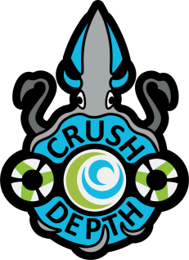
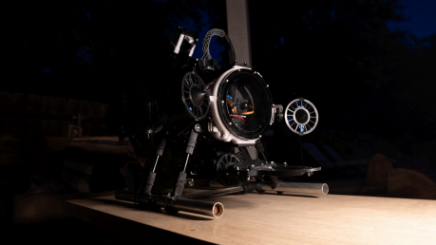Team Members:
Daniel Silguero | CEO & Pilot | 2024
Lauren McLaury | Co-President & Software| 2024
Rana Eyit | Co-President & Design | 2025
Robert Voss | CTO & Software Lead | 2025
Gevorg Kareyan | Mechanical Lead | 2026
Maxine Catahan | Safety Lead| 2025
Alex Brezny | Software | 2024
Olaf Martinez | Mechanical | 2025
Alex Liang | Software | 2025
Mentor:
Gurinder Khaira | Mechanical
CRUSH DEPTH | 1
Table of Contents
1.Abstract ------------------------------------------------------------------- 2.Design Rationale -------------------------------------------------------- a.Design Evolution -------------------------------------------------- b.Mechanical --------------------------------------------------------- c.Electronics ---------------------------------------------------------- d.Software ------------------------------------------------------------ e.Trouble Shooting ------------------------------------------------- 3.Non-ROV Device: Vertical Profiling Float ------------------------- 4.Safety ---------------------------------------------------------------------- a.Safety Philosophy ------------------------------------------------- b.Operational Safety ------------------------------------------------ c.ROV Operational Safety ----------------------------------------- 5.Logistics ------------------------------------------------------------------- a.Company Organization
b.Collaborative Workspace ---------------------------------------- 6.Conclusion ---------------------------------------------------------------- a.Challenges -----------------------------------------------------------
b.Future Improvements --------------------------------------------- c.Acknowledgments ------------------------------------------------- d.References -----------------------------------------------------------
7.Appendix ------------------------------------------------------------------- a.Gantt Chart ---------------------------------------------------------- b.Budget ---------------------------------------------------------------- c.Cost Accounting ---------------------------------------------------- d.ROV SID --------------------------------------------------------------- e.Float SID --------------------------------------------------------------
3
4
4
5
8
10 11 13 13 13 13 13 14 14 15 15 15 15 15 16 17 17 18 19 20 21
CRUSH DEPTH | 2
Abstract
Crush Depth is a first year Pioneer company comprised of students attending Clovis Community College located in Fresno, California. All employees of Crush Depth have prior engineering or robotics experience. Despite only including one employee with prior MATE ROV experience, Crush Depth is fully qualified and equipped to accomplish tasks set before the company. Using experience and education, the employees have combined their individual strengths to cohesively design and build a Remotely Operated Vehicle (ROV) named Percy. Percy has been designed with simplicity and versatility in mind, featuring a compact and agile aquadynamic profile. With two manipulators, one in the front and back, Percy is able to complete a variety of ocean conservation tasks. With six T200 thrusters allowing for five degrees of freedom, Percy navigates through the water with ease.
Crush Depth has also implemented a non-ROV device (Float) to profile the water, collecting temperature and depth readings. This allows the company to use its resources as effectively as possible. The data collected by Crush Depth’s Float can be used to analyze the ocean water’s properties. The Float utilizes a stepper motor buoyancy engine to complete full-depth profiles of the ocean. The Float wirelessly transmits its data back to the topside control center, where the analysis can be done, and resources can be distributed as necessary.
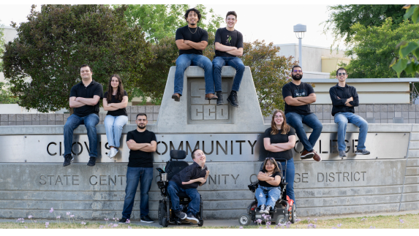Figure 1. Crush Depth team photo taken by Bishop Hockman
CRUSH DEPTH | 3
Design Rationale
Design Evolution
All engineering creations begin with an idea – Crush Depth’s ideas successfully transformed from concepts into a product design reality. To comply with MATE’s requirements for creating complex large-class devices, Percy’s design journey had to overcome technical difficulties through numerous design iterations. Selecting the right design was one of the most difficult challenges for the company. The company focused on various schemes and designs continuously, analyzing the characteristics and identifying the advantages and disadvantages of different designs.
After a lengthy search, the company identified a design where the entire structure is based on a tube frame that carries the claw and power system. With this idea serving as the grounding principle, Percy turned out to be lightweight, maneuverable, and easily repairable.
SolidWorks 2023 was the CAD software utilized to design Percy. This software provided opportunities to create, assemble, and test mechanical and electromechanical components of the ROV. Multiple prototypes were developed after designing the Percy ROV on CAD to test and advance through the building process.
Figure 2. Robot CAD model by Design Team
CRUSH DEPTH | 4
Mechanical
Frame
The frame is one of the most important parts of any machine or device. During the development of the framing concept, the main design objective was
to maximize the material strength-to-weight ratio. The company experimented with different filaments during the design process to test their temperatures and densities. The company chose ABS plastic based on its strength and characteristics. Crush Depth achieved a maximum structural strength with minimal weight ratio, which led to a large majority of all mechanical and frame components being 3-D printed with ABS plastic.
Percy’s frame is comprised of 5 principal ring parts. The basis for the frame is a 15.24 cm plexiglass tube, which houses the electronics. The rings are secured to the tube and each other with M6 bolts. The 5 main rings evenly distribute the forces of all attachments, including thrusters and manipulator components, on the core cylinder of Percy. M6 and M3 bolts connect 6 thruster mounts which supports 4 translational and 2 lifting thrusters. On the upper side of the frame, there is a 6 mm thick plate connected with the rings with M3 bolts that hold the tether strain relief and secondary manipulator. On the lower side of the frame, a second plate is attached using M3 bolts, which are completely identical to the first and hold the main manipulator and its 2 NEMA-17 step motors.
Figure 3. The Frame of Percy by Gevorg Kareyan
Manipulators
The design for Percy’s main working tool presented a challenging task for the company. After thorough research and testing distinct designs, it became evident that no existing prototype met the company's requirements. As a result, Crush Depth made the bold decision to create a design from scratch that aligns with company standards and needs. Percy consists of two manipulators: one in the front and the other facing the back of the frame. All subcomponents for these manipulators are 3-D printed with ABS plastic with a 100% infill. The primary mechanical manipulator (Figure 4) serves as the main working tool for Percy. It boasts 2 degrees of freedom, allowing it to grab objects, and rotate them an unlimited amount of revolutions. Comprised of 22 plastic parts, the primary manipulator relies on an aluminum pipe with a 13.2 mm outer diameter to bear a majority of the total mechanical load.
Its core elements include two semicircular pincers (claws) for gripping objects, arms and arm holders connected to the main claws and shafts, as well as rotational gears and lead screws. The rotational gears meet ISO standards with a ratio of 1:8 and are 3-D printed with Nylon plastic. The lead screws are responsible for object grabbing and are connected to the main shaft.
Percy's system integrates a secondary manipulator designed for small-sized loads. Although identical to the primary manipulator in terms of parts and components for grabbing, the secondary manipulator focuses solely on the grabbing function, which is crucial for executing special tasks. The secondary manipulator can be folded for transportation. By optimizing two manipulators, the company has expanded the functionality of Percy, enabling it to perform additional complex tasks.
CRUSH DEPTH | 5
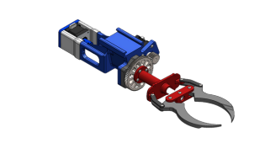Figure 4. Primary manipulator by Gevorg Kareyan 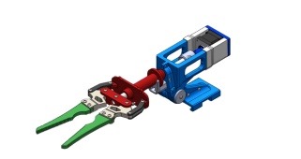Figure 5. Secondary manipulator by Gevorg Kareyan
Tether
The 22.86 meter ROV tether is a crucial component of the Percy platform delivering power and control data from the operations station to the vehicle and returning video and invaluable mission information from the vehicle to the pilot's co-pilots and mission specialists. The tether is comprised of multiple crucial components each with a specific role.
Power
Power is delivered to the ROV through a twelve gauge low-voltage landscape lighting wire. This puncture-resistant flexible cable is designed to be buried, which provides optimal durability and flexibility while efficiently delivering power to the ROV .
Data
Data is transmitted through the tether via one length of cat six ethernet cable. The high-quality ethernet cable chosen is effectively shielded from all the electromagnetic turbulence induced by Percy’s motors allowing consistent transmission of video and important mission data without interruption.
Figure 6. Tether by Olaf Martinez
Buoyancy
With multiple cables running down to the ROV Crush Depth are needed to ensure the weight of the tether would not compromise the performance or interfere with the maneuverability of the platform. To address this issue one length of 1.27 cm foam rope was run alongside the data and power cables to create neutral buoyancy and negate the effects the tether has on the vehicle's maneuverability and aquatic efficiency.
Sheathing
All the components of the tether can easily become tangled and separated to address this issue crush depth enclosed all cables and floatation in a single length of 1.27 cm wire sheathing. This thin black cover sheaths and protects all the cables while preventing tangles and complications during deployment operation and recovery.
CRUSH DEPTH | 6
Buoyancy
When developing a remotely operated submersible vehicle a crucial component to be considered to ensure effective translation through the water is the buoyancy and ballast system. Without a properly balanced vehicle completing the required tasks and missions becomes increasingly more difficult. The Crush Depth Mechanical Team worked tirelessly to ensure optimal ballast and buoyancy was utilized to optimize the vehicle's capabilities.
Buoyancy
The buoyancy of the robot is controlled by modifying the existing components to create an ideal net buoyancy. The first component is an 8-inch (20.32 cm) plexiglass tube, i.e., the electronics enclosure (Figure 9). The primary function of this air-tight enclosure is to protect Percy’s sensitive electrical components from harsh aquatic environments that the ROV might encounter. A secondary function of the enclosure is to contribute to the buoyancy of the vehicle. To fine-tune the buoyancy of the vehicle further, two square rods of high-density foam were placed on the top sides of the robot reinforcing marine stability and balancing the platform.
Ballast
The ballast of the vehicle is just as important as buoyancy components. These denser-than-water objects are mounted to the bottom half of the ROV to bring the bottom of the Vehicle down while the floatation pulls the top up, this combination causes the vehicle to remain upright and stable in any condition. The ballast system implemented on Percy utilizes two main pieces. Steel rods and aluminum tubing. The 2.54 cm aluminum tubes (Figure 8) each house a 20.32 cm length of steel rod. The steel rod can be manually moved forward or backward to fine-tune the center of gravity independently on the port and starboard sides of the vehicle.
Figure 7. Percy’s Platform Olaf Martinez Figure 8. Percy’s Platform Olaf Martinez
CRUSH DEPTH | 7
Propulsion
As a company, Crush Depth wanted to ensure optimal efficiency, practicality, and versatility. when developing the perfect vehicle. To do this multiple thruster layout concepts were considered. After extensive research discussion and concept crafting the Percy platform was born (Figure 8).
Utilizing six Blue Robotics T200 thrusters This design would allow a powerful and reliable level of control whilst maintaining a simplistic and cost-effective design. The Percy platform is capable of several axes of movement. The four horizontally placed thrusters are capable of rotating and translating the vehicle in the xy axis, while the two vertically placed motors are capable of providing strong lifting capacity in the z-direction.
Electronics
Electrical Systems
In order to relay commands to Percy, Crush Depth implemented a multi-part electrical system that depends on several crucial components working together to function effectively (Figure 10). The system starts with the USB to ethernet interface. This interface transmits and receives data through a 22.86-meter ethernet tether delivering crucial commands to the underwater operations system and returns mission data and video feeds. USB inputs on Percy convert into an ethernet signal that is then converted back into a USB signal on the surface for the control PC to interpret. This critical component allows the connection of onboard Arduino, cameras, and temperature sensors to the surface-side PC through a direct USB connection.
Once the connection is established, the onboard Arduino sends all commands to Percy’s systems effectively via PWM (Pulse Width Modulation) and stepper signals.
These systems include the 6 blue robotics brushless speed controllers, a camera servo motor, and the stepper motor shield.
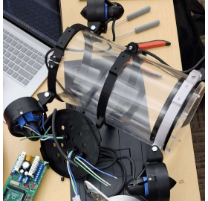
Figure 9. Electronics Enclosure by Daniel Silguero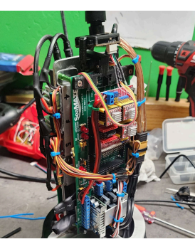Figure 10. Electrical System by Daniel Silguero
CRUSH DEPTH | 8
The stepper motor shield receives stepper signals from the onboard Arduino and commands three A4988 stepper motor drivers each controlling a single stepper motor. The stepper motors are responsible for running manipulators.
The second crucial electrical component entering the watertight enclosure is 48 DC volts. The current is split into 3 different locations on the vehicle. The first is Percy’s subsea PCB which uses multiple DC-DC converters to supply 12 and 5 volts to crucial instruments along with providing signal data transportation from the Arduino to easily accessible PWM pins where the blue robotics Speed controller's signal wires interface.
The voltage not sent to the PCB is delivered to two separate but equally important DC-DC converters. The first is a 48V to 12V 33 amp converter supplying voltage to two of Percy’s speed controllers. The second is a 48V to 12V 60 amp converter supplying power to the remaining four-speed controllers.
Lastly are the ever-so-important blue robotics brushless speed controllers. These small control boards capable of supplying 30 amps to each of Percy’s thrusters receive 12 volts from the CD-DC converters along with PWM signals from the PCB Arduino pins to command six T200 thrusters.
Electrical Housing
To house Percy’s electrical components, an 8-inch (20.32 cm) Blue Robotics watertight plexiglass enclosure was utilized. This durable enclosure acts as an air-tight protective environment for ROV components that are too difficult or delicate to waterproof independently.
Sensors
With an open-source and versatile platform, the Crush Depth electrical team worked to ensure rapid sensor integration. The current model features a simple yet reliable USB temperature sensor plugged directly into the native USB hub located within the canister. This same USB hub can be used to quickly add USB-capable sensors and equipment. For non-USB sensors, the control PCB features multiple auxiliary power and data inputs capable of running more than twenty additional sensors or auxiliary systems.
Cameras
Percy’s camera array utilizes three USB webcam modules. The three independent cameras each have a crucial role in the operation and versatility of the vehicle. The main forward-facing camera (Figure 11) allows Percy’s pilot and copilot to view the bow of the vehicle and its associated front manipulator. The rear facing camera features a 180-degree fisheye lens allowing the pilot to see both the aft manipulator and assist in rapid navigation while returning or collecting mission-critical equipment. The third camera is the portside camera. This camera angle's main purpose is to collect images utilized in the photogrammetric rendering of coral reefs and other subjects observed by the vehicle.
Figure 11. Forward-Facing Camera by Olaf
CRUSH DEPTH | 9
Software
Programming Structure As the most experienced programmer in Crush Depth, the CTO gave the software team insight on how to manage large-scale, in-depth projects such as the one this company has undertaken. As a result of their guidance, software tasks were broken down into three facets: user interface, embedded systems, and image processing.
User Interface
The user interface for Crush Depth’s underwater operation system consists of two parts: the Graphical User Interface (GUI) and the multi-joystick input system.
The GUI houses the live video feeds from the onboard cameras, readings from the temperature probe, float status, and live motor positions and speeds. The GUI will also have a feature for switching to different layouts that will allow different combinations of camera views for the pilot. The flightsticks we are using have multiple axes per joystick allowing for several different control schemes. With the current control scheme, the pilot controls all ROV movement with the two joysticks, and the co-pilot presses buttons on the same sticks to control the claws. The joystick inputs go into the Python program.
Embedded Systems
The pipeline of inputs and outputs for Percy starts at the flight sticks which feed into the onshore computer where the main Python program reads their input, packages it up, and sends it over the tether to the Arduino. The Arduino must then unpack the data which determines the values to plug into the calculations. The results of the calculations are then sent to the motors as PWM signals. The Arduino then collects data from the sensors, packages it, and sends it over the tether to the Python program. The Python program unpacks the Arduino data which is then used to update the GUI values. This defines the main loop that repeats continuously during Percy’s operation.
Data is sent over the tether using the serial communication protocol. Data is packaged using JavaScript Object Notation (JSON) documents.
Image Processing
The programming team has no prior experience with photogrammetry, so a large portion of the programming research was focused on this task. After looking at examples and documentation, we first decided upon using Meshroom. This unfortunately was very slow to render an image, far exceeding the allotted time for each run, so the team decided to start anew. After consulting more forums and past participants we pivoted to using RealityCapture instead due to anecdotal performance improvements and ease of use.
Figure 12. Percy’s top view by Design Team
CRUSH DEPTH | 10
Development
The control system that Crush Depth decided on requires the use of a computer and Arduino Mega (arduino). Those two devices must be in constant communication with each other, presenting a large obstacle to the programming team. The CTO who was in charge of the vital ROV operations started by breaking down the example Arduino code provided to Crush Depth by MATE. This example code was instrumental in getting “up to speed” with how the thrusters needed to be programmed. The next step in development was to get communication over Serial working between the company laptop and the arduino. The first step for this was using the Arduino IDE’s built in Serial Monitor tool to send thruster values to the arduino. Once this was successful it was time to connect our main onshore program to the arduino control program using python. The python program was designed at first to programmatically send values over the open COMM port to the arduino using JSON which was then unpacked and sent to Percy’s thruster (only one thruster was being used at this time). Implementing the flight sticks was the next step taken, still with only one thruster. Once this was successful the CTO wrote a custom class for thrusters to allow for more modularity and easier modification of code. Setup code for each new thruster was reduced to one line of code instead of the typical 4-5. The next step was to incorporate all 6 thrusters into the team’s test program which was made significantly easier by using an array of our custom thruster class to loop over and extract data from the JSON document. A similar process was used to complete code for the servos and stepper motors used for the cameras and manipulators.
Research has also been started on how to complete the autonomous tasks, it has been decided however that these mini-programs will be launched by pressing buttons on the flight sticks. The GUI is also being continuously updated according to driver requests.
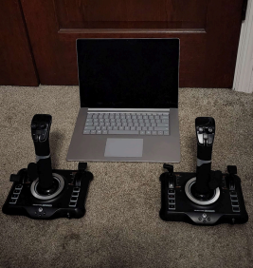Figure 13. Control system by Daniel Silguero
Troubleshooting
Crush Depth encountered a slew of challenges and setbacks during the development of the Percy subsea platform. These challenges were overcome through hours of rigorous troubleshooting, testing, redesigning, and innovation to create a reliable and effective system. Due to resource constraints, Crush Depth's development and problem-solving took a unique approach. Utilizing a single controlled testing environment shared by all the company’s departments, optimizing company testing strategies to safely develop, test, and repair multiple ROV components simultaneously in one testing environment. Crush Depth and the Percy platform faced several electrical setbacks throughout its development. The first was the failure of crucial electronic thruster controllers.
CRUSH DEPTH | 11
These brushless speed controllers are one of the
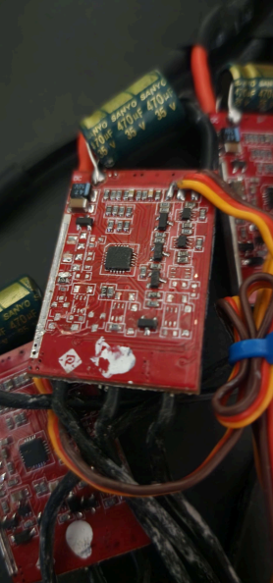
significant components of the robot's functionality,
commanding the T200 thrusters to move the platform
through its environment. A generic budget-friendly
multi-direction 30 amp brushless ESC (electronic speed
controller) was chosen to reduce costs. Theoretically,
this component, costing half that of the leading Blue
Robotics basic ESC, would provide equivalent
performance at a far more competitive price, however,
this was not the reality. In bench testing, the speed
controllers performed as expected; however, once
integrated into the vehicle, the limitations of these
components were found relatively quickly. Despite
installing the speed controllers in optimal locations to
allow proper heat dissipation, the components designed
for aerial vehicles could not be cooled effectively due to
the unique environment and heavy use of the T200
thrusters. Ultimately, the ESCs began to melt,
unsoldering their components and failing (Figure 14). At
first, the cause of this issue was not evident; multiple
causes were considered and tested, including the supply
voltage and amperage drawn from each motor;
eventually, after concluding that the speed controller
should not have failed, two Blue Robotics ESCs were
implemented and tested utilizing the same T200 motors
under both identical and more rigorous testing
conditions. The higher-quality blue robotics controllers
overcame the challenge and performed perfectly under
the strict testing conditions. Crush depth has since
exclusively implemented blue robotics speed
controllers.
One issue the programming team ran into was the
orientation of our joysticks in relation to our thruster
configuration. This was corrected by referencing MATE’s
code and drawing diagrams to determine correct
positive/negative values. Similar processes were
followed for the stepper motors with the main
difference being that they are controlled with buttons
_{instead of joystick axes.} Figure 14. Failed ESC by Daniel Silguero
CRUSH DEPTH | 12
^{Non-ROV Device} Safety
The float is built from a 3-inch PVC tube with a length of 49.8 cm. As the float system will not have any thrusters to move in the water, a water-based buoyancy engine is used. This engine utilizes density to sink, float, or stay neutral. The system consists of three 60 cc syringes connected to a cap. This cap is connected to a rod and is attached to a NEMA-17 step motor (Figure 15). On the upper side of the buoyancy engine, sensors and Rasberry Pi 4B are stored.
The float utilizes a state machine using limit switches to transition between states. It has three states: descending, ascending, and transmitting data. During the ascending and descending states, data will be collected with a pressure sensor. Data transmission occurs at the surface between the transition of the other two states. Data is transmitted over wifi using similar packaging methods as data transmission over the tether. It will continue with the current state until a limit switch has triggered a state change or data transmission has been completed.
Figure 15. Float by Gevorg Kareyan
Safety Philosophy
Crush Depth aims to prevent any possible accidents and injuries in advance by putting the safety of its employees as a priority. The company used MATE’s safety guidelines as a foundation to create a versatile safety protocol. To ensure the company abides by the safety protocol, a safety lead was appointed at the start of competition season.
Operational Safety
Safety glasses are worn when using power tools. Employees always wear close-toed shoes.
Long hair, hoodie strings, and other loose pieces must be secured before entering the work area. Employees must be trained before using any machine.
No running in the working area or near the pool deck.
Any mistake or incident should be reported to leadership to implement an effective solution.
ROV Operational Safety
Crush Depth dedicated numerous hours to ensuring Percy met and exceeded all safety guidelines outlined in the 2024 competition manual. On top of this, employees follow an extensive safety protocol checklist before attempting to operate the ROV. During operation, the following safety rules are implemented:
Employees ensure that all items are attached to the ROV and no cables are exposed.
The driver team alerts everyone about starting the missions.
The tether is maintained by the pool crew for any emergency.
The drive team informs everyone that the mission ended.
CRUSH DEPTH | 13
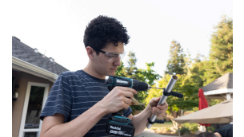Figure 16. Safety Regulations by Olaf Martinez Logistics
Company Organization
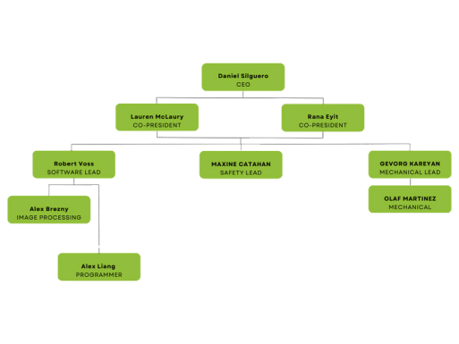
Crush Depth is a small community college-based team with a structured leadership system divided into three main categories: Software, Safety, and Mechanical. The Software category is further divided into General and Image Processing sections, each with its own focus and expertise.

Each category is managed by a dedicated lead, ensuring focused attention and expertise in their respective areas.
These leads are responsible for overseeing their sections and guiding their team members as they work to find innovative solutions. The leads from each category report to the Co-Presidents, who play a pivotal role in maintaining cohesion and addressing any issues that arise across the team. The Co Presidents are also responsible for liaising with the CEO, ensuring that the team's activities align with the overall vision and goals of the organization. Both the CEO and the Co-Presidents are responsible for assigning tasks, managing the budget, and handling all documentation related to funding through the school. This includes ensuring proper allocation of resources and maintaining transparency and accountability in financial matters. This structured approach promotes efficient communication, clear responsibilities, and a collaborative environment within the team, fostering innovation and effective problem-solving.
Figure 17. Company Organization Chart by Rana Eyit
CRUSH DEPTH | 14
Collaborative Workspace
The company utilizes a cloud storage system, including platforms like Google Drive, Canvas, and Discord, to facilitate remote work. Google Drive is used to store meeting minutes, 3-D designs, and any documentation that the company might need in the future, ensuring that all critical information is easily accessible and well-organized. Discord is employed to maintain constant communication and collaboration among team members, enabling them to share updates and resources seamlessly. By leveraging these digital tools, the team ensures that all members have access to necessary resources and can contribute to projects in real-time, promoting flexibility and productivity.
Experience Gained
Throughout the build season, the company and its members attained valuable hands on skills and experience through troubleshooting and team work. The opportunity to participate in MATE ROV has served as a powerful introduction to high stress, collaborative projects. These skills are invaluable when preparing Crush Depth’s dedicated students for future career positions.
Conclusion
Challenges
The challenges were great, yet Crush Depth did not waver in the face of adversity. Being a first year company, many pitfalls and shortcomings were difficult to avoid when lacking the veteran experience prevalent in the larger competition companies. With one member being a previous MATE participant, the team had a slight idea of the direction. However, progress was slow, barely gaining traction halfway through the competition season. Despite the late start, Crush Depth pulled through and presents a competitive platform and is excited to show the world what is possible.
Future Improvements
In the future, Crush Depth aims to focus on maintaining a lower profile footprint while dedicating more time to developing compact manipulators and mission tools.
Acknowledgements
Crush Depth would like to express deepest gratitude to the following individuals and organizations who have supported the company throughout this ROV journey:
Clovis Community College provided crucial funding that allowed the purchase of high-quality
components such as the additional T200 thrusters, USB cameras, more resilient speed controllers, and high-performance USB joysticks. Moreover, they also granted the company access to 3D printers and 3D filaments for rapid prototyping and production. Cyclonetics Corporation, a CNC manufacturing company that donated materials and provided access to machines that allowed the production of crucial vertical profiling float components, including the end caps and O’ring flanges.
MATE ROV and the Marine Technology Society special project grant, a contributor to the material for getting started with the MATE robotics competition. These materials include tether materials, a power supply kit for testing, PCB for ROV control, 4 T200 thrusters with speed
controllers, and a 20.32 cm watertight enclosure. Mr. Khaira, the company’s advisor, for the time, guidance, cheerleading our project, and dedication to the workspace.
CRUSH DEPTH | 15
References
1.
Blue Robotics T200 Thruster.
https://bluerobotics.com/store/thrusters/t100- t200- thrusters/t200-thruster-r2-rp/
2.
Blue Robotics 6” Watertight Enclosure.
https://bluerobotics.com/store/watertight enclosures /non-locking-series/wte6-p-tube-12-r1/ 3.
Raspberry Pi 4.
https://www.raspberrypi.com/products/raspberry pi-4-model- b/specifications/
4.
MATE ROV Competition Website.
https://materovcompetition.org/
Figure 18. MATE ROV logo by MATE ROV Competition
Figure 19. MTS logo by MATE ROV Competition
CRUSH DEPTH | 16
Appendices
Gantt Chart
Table 1. Gantt Chart by Maxine Catahan
CRUSH DEPTH | 17
Budget
Table 2. Budget by Rana Eyit and Lauren McLaury
CRUSH DEPTH | 18
Cost Accounting
Table 3. Cost Accounting by Rana Eyit and Lauren McLaury
CRUSH DEPTH | 19
ROV SID
CRUSH DEPTH | 20
Float SID
CRUSH DEPTH | 21

